IT2525/IT2130 Cyber Forensic Technologies & Process

AY2026 Semester 2

Practical 1 – Storage File Systems

Learning Outome
To understand, examine and explain various industry standard file system formats used in different operating systems.

After this practical lab, you will able to:

- Use ‘AccessData FTK Imager’ to examine, locate and describe the evidence in

  - MBR
  - FAT file system

Task 1
Examine, locate and explain the file system parameters and evidence in a given disk image file.

Instructions

- You may use the VM provided in SIT Lab or install ‘AccessData FTK Imager’ [link provided in Politemall] in your own laptop.
- Download a copy of the disk image file 123456A-FAT32.E01 from Politemall.

- Use AccessData FTK Imager to examine the disk image file.

Question 1
  - Locate Master Boot Record (MBR) in physical sector 0, and take a screenshot of the partition table in the Master Boot Record (MBR)
(Note: Refer to the slide “Structure of a Generic MBR: in Week 1 lecture note”)

ANSWER AT LAST PAGE.

  - For each of the non-zero partition entries in the partition table, use rectangles to mark the following parameters.
    - Active or inactive partition
    - Partition type
    - Starting sector of the partition
    - Size of the partition in sectors

  - Examine the parameters in the partition table and fill the parameters in the partition table below.

Entry | Active or  inactive | Partition Type (e.g.  FAT32) | Starting sector of the partition in decimal | Size of the partition in sectors (in decimal)
1 | 0x00, Inactive | 0x0B, FAT32 with CHS Addressing | Hex – 0x00000008  Decimal - 128 | Hex – 0x00096000  Decimal - 614,400
2 | 0x00, Inactive | 0x06, FAT16B | Hex – 0x00096080  Decimal – 614,528 | Hex – 0x00096000  Decimal – 614,400
3 | 0x00, Inactive | 0x07, NTFS/exFAT | Hex – 0x0012C080  Decimal – 1,228,928 | Hex – 0x000D2800  Decimal – 862,208

Refer to the file FAT12 FAT16 and FAT32 file system formats this week Tutorial Appendix in Politemall to examine the 3 file system components: VBR, FAT, and Root Folder in the first FAT32 file volume of the disk image file.

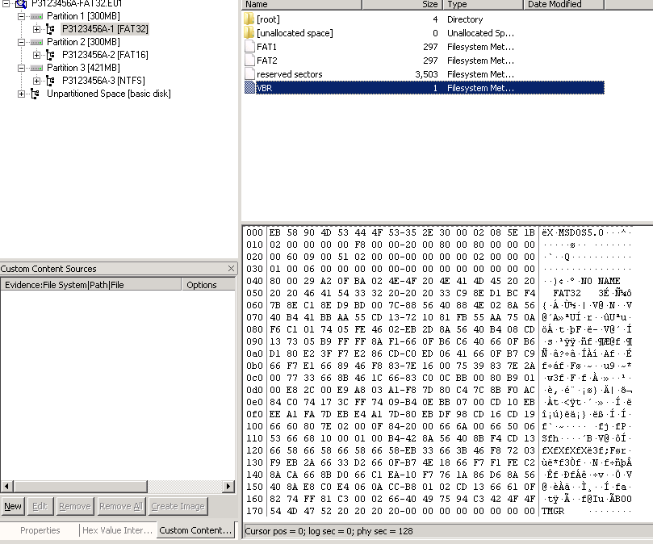
  - Click to select the Volume Boot Record (VBR) in the first simple volume of the disk image

  - Capture the screen that shows the parameters of the first 90 bytes (offset 0x00 to 0x5A) of the VBR.

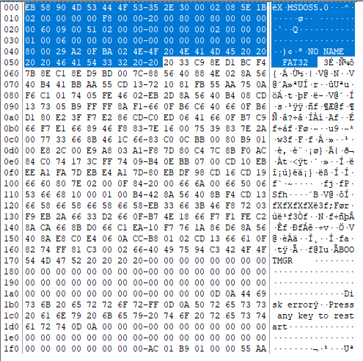

  - Refer to the FAT32 File System Format. What is the size (in bytes) of a sector in the file system? Mark the size of a sector parameter in the captured screen (similar to the image below) 512

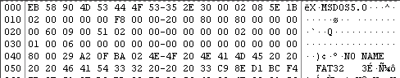

  - What is the number of sectors in a cluster in the file system? 8

  - Click the folder [root] (Root Folder). What is the logical sector number that stores the Root Folder?

  - Examine the hexadecimal values in Root Folder.

Browse to locate the file record for win10_20170323.pdf in Root Folder

What is the short filename (an 8.3 filename) of the file win10_20170323.pdf in Root Folder? WIN10~1.PDF
Capture the screen to show the file entry win10_20170323.pdf in Root Folder.

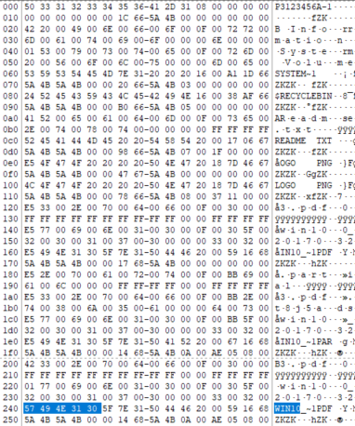

Below is a sample screenshot for the file entry for Readme.txt

  - Find the size, the first cluster number and the last cluster number that store each of the following files. Put your answers in the following table.

File Name | Size in bytes  (decimal) | First Cluster  (in hexadecimal) | Last Cluster  (in hexadecimal)
Readme.txt | 31 | 0x0007 | 0x00000007
logo.png | 4407 | 0x00000008 | 0x00000009
win10_20170323.pdf | 525,472 | 0x0000000A | 0x0000008A

A sample of FAT of a FAT32 file system is shown below
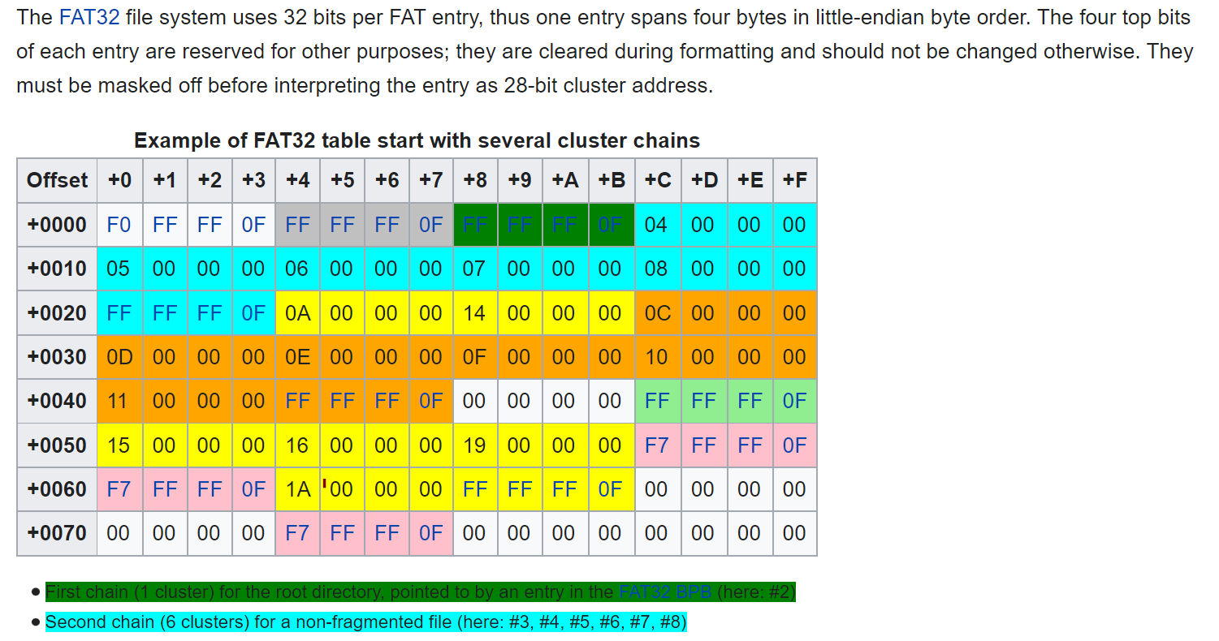

QUESTION 1a) :


